**What tech stack will you use for your final project? We recommend that you use React and Node for this project, however if you are extremely interested in becoming a Python developer you are welcome to use Python/Flask for this project.**

I plan to use React and Node for this Project.

**Is the front-end UI or the back-end going to be the focus of your project? Or are you going to make an evenly focused full-stack application**

This project will focus more on the back-end as I will be creating my own API.

**Will this be a website? A mobile app? Something else?**

This will be a website.

**What goal will your project be designed to achieve?**

My goal is to create a website that will allow users to find information about the fish and corals in the aquarium hobby. I will also have a section in the website with all my for sale..

**What kind of users will visit your app? In other words, what is the demographic of your users**

Users that are into the saltwater aquarium hobby will be my main demographic for this.

**What data do you plan on using? How are you planning on collecting your data? You may have not picked your actual API yet, which is fine, just outline what kind of data you would like it to contain. You are welcome to create your own API 7. populate it with data. If you are using a Python/Flask stack are required to create your own API.**

I plan on compiling my own data for this projectI. Reason for doing this is because i did not find an existing API that will provide me the information i need to create this website

**In brief, outline your approach to creating your project (knowing that you may not know everything in advance and that these details might change later). Answer questions like the ones below, but feel free to add more information:**

**A) What does your database schema look like?**

Currently, I have planned 4 independent tables consisting of users, corals, saltwater_fish and corals_for_sale

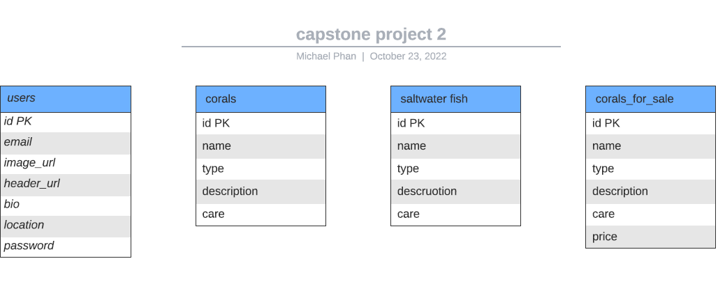

**B) What kinds of issues might you run into with your API? This is especially important if you are creating your own API, web scraping produces notoriously messy data.**

The biggest issue is gathering all the data I need to populate my database. I understand web scraping can be very troublesome at times so I am prepared to extract the data from websites manually if that doesn't work out.

**C. Is there any sensitive information you need to secure?**

Yes, users will be required to create a profile and login to have full access to the website

**D. What functionality will your app include?**

Users will have the ability to search for aquarium fish, and corals.

**E. What will the user flow look like?**

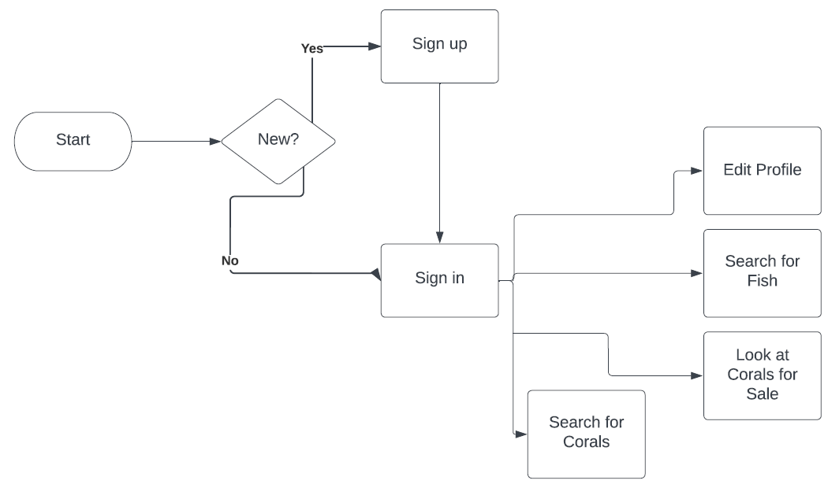

**F. What features make your site more than a CRUD app?**

Users will be able to learn about the aquarium hobby and shop for corals